

KARUK TRIBE HOUSING AUTHORITY
REQUEST FOR LUMP SUM FIXED QUOTATION

SOLICITATION FOR LUMP SUM FIXED-PRICE QUOTATIONS BASED ON PRICE ONLY
($250,000 or less per Activity)

Due Date: Friday, August 30, 2024, by 5:00pm
Mandatory Site Visit: By appointment, contact Project Manager, Brian Gonzalez
More Information: Brian Gonzalez, (530) 643-6177, bgonzalez@karuk.us

- The Karuk Tribe Housing Authority (KTHA) requests lump sum fixed-price quotations for all necessary materials, labor, equipment, and tools needed for tree removal and clean up at Karuk Tribe Housing Authority, 1836 Apsuun Rd. Yreka, Siskiyou County, CA 96097.

- KTHA is requesting these quotations under its small purchase procedures. This is a less formal, simplified process which does not require sealed bids and will help us to expedite our selection. We will not accept quotations that are more than $250,000 per Activity.

- Quotations are invited from non-Indian as well as Indian-owned economic enterprises or organizations.

- Quotations may be submitted by fax, email, mail, or hand delivery. All quotations must be submitted to KTHA in writing and can be emailed to fwolfenden@karuk.us, mailed or hand delivered to PO Box 1159, 635 Jacobs Way, Happy Camp, CA 96039 by Friday, August 30, 2024 by 5:00pm.

- The Scope of Work is as set forth on Appendix A attached to this Solicitation. Anyone submitting a quotation for this work must visit the job site(s) to ascertain the nature and location of work and to satisfy itself as to the general and local conditions which can affect the work by attending a mandatory site visit, to schedule an appointment contact Brian Gonzalez, at (530) 643-6177 or bgonzalez@karuk.us.

- Indian Preference. Any firm seeking Indian preference in this award must provide evidence that it is not less than 51% Indian owned and controlled. If claiming this preference, please contact us immediately so that we can fax you a pre-qualification statement that you must fill out and return within two days of your receipt. KTHA will then review the statement and determine eligibility for preference.

- Award. The contract will only be awarded to a responsive, responsible individual or firm. The contract will be awarded to a qualified Indian enterprise submitting the lowest responsive quotation if such quotation is within budgeting limits established for this solicitation and is within the limits identified in the KTHA Procurement Policy regarding Indian preference in contracting. If no responsive quotation by a qualified Indian enterprise is within the above-stated limits, then award will be made to the individual or firm with the lowest responsive quotation.

- All quotations must contain a commitment to provide Indian preference in 1) subcontracting, 2) training, and 3) employment, and must contain a statement describing the methods that will be used to provide such preferences. This statement is part of the submitted quotation. This statement will be evaluated as part of the submitted quotation, and any quotation failing to contain such preference statement or failing to adequately address such preference requirements shall be deemed non-responsive. If you believe it is infeasible to provide Indian preference in subcontracting, training, or employment, you must include in your quotation a certification as to the reasons why.
- The form of Contract which contains the terms and provisions of the contract agreement between KTHA and the individual or firm selected for this work is available for review upon request. By submitting a quotation, you hereby agree that if selected, you shall deliver to the Authority, within the time later designated by the Authority, a properly executed Contract and to be bound by all terms and conditions set forth therein, including but not limited to assurance of performance, completion dates, prevailing wage rates, warranties, other federal requirements, and other terms and provisions as set forth therein.

- All quotations must commit to remaining open for at least 45 days.

- The selected contractor will be responsible for paying all Tribal license fees and taxes, as well as permits that may be required, if any.

- The successful individual or firm on this solicitation must comply with the Tribe’s TERO Ordinance, including any licensing requirements. This includes, but is not limited to, paying a 2% TERO fee on the work to be performed. Tribal minimum wage rates shall apply. For a copy of the TERO Ordinance and more information, the Karuk Tribe TERO Director, should be contacted at (530) 493-1600 ext. 2030.

- All bidders acknowledge that Karuk Tribal Sales Tax is 6% and will be paid for all materials purchased in conjunction with this contract. Contractor shall apply for and receive a California Seller's Permit (AKA: California State Board of Equalization Resale Number) prior to the commencement of work under this contract. The requirement for the Seller's Permit is to allow the Contractor to obtain materials and fixtures from the supplier without paying tax. The Contractor may then resell the materials and fixtures to the Owner on Karuk Tribal Lands before installation. Nothing herein shall allow the Contractor to charge more than the actual price/value of the materials and fixtures provided. Title to the materials and fixtures transfers to the Owner (Karuk Tribe Housing Authority) on the Karuk Tribal Lands and prior to the installation of the materials by Contractor.

- This solicitation does not commit KTHA to award a contract or to pay any costs incurred in the preparation of quotation or the procurements of supplies. KTHA reserves the right to reject any and all quotations or to re-solicit when it is deemed by KTHA to be in its best interest to do so.

- If there are any questions, please contact Brian Gonzalez, Yreka Maintenance Supervisor, (530) 643-6177, bgonzalez@karuk.us. KTHA will let you know the decision of the award.

APPENDIX A
To Request for Lump Sum Fixed-Price Quotation

SCOPE OF WORK

Work shall include all necessary labor, equipment, and tools needed for tree removal and clean up at Karuk Tribe Housing Authority, 1836 Apsuun Rd. Yreka, Siskiyou County, CA 96097 as outlined further below:
- Contractor shall be responsible for complete removal of 2 large trees and roots, with no stumps left behind.

- Contractor must include making sure the hole is backfilled and compacted with native soil after complete removal and leveled to the original grade.

- Contractor is responsible to clear the jobsite of all debris resulting from the tree and stump removal and will be held responsible for any damages done to the adjacent properties.

- Contractor shall be properly licensed and insured for the work to be completed.

- All bidders must complete a mandatory site visit by scheduling an appointment with Brian Gonzalez, at (530) 643-6177 or bgonzalez@karuk.us

- All bids must include a TERO fee of 2% on the total bid amount, and 6% Tribal Sales Tax on the total of all materials. Tribal wage rates (as attached) and Indian preference will apply.

APPENDIX A
To Request for Lump Sum Fixed-Price Quotation

TRIBAL WAGE RATES

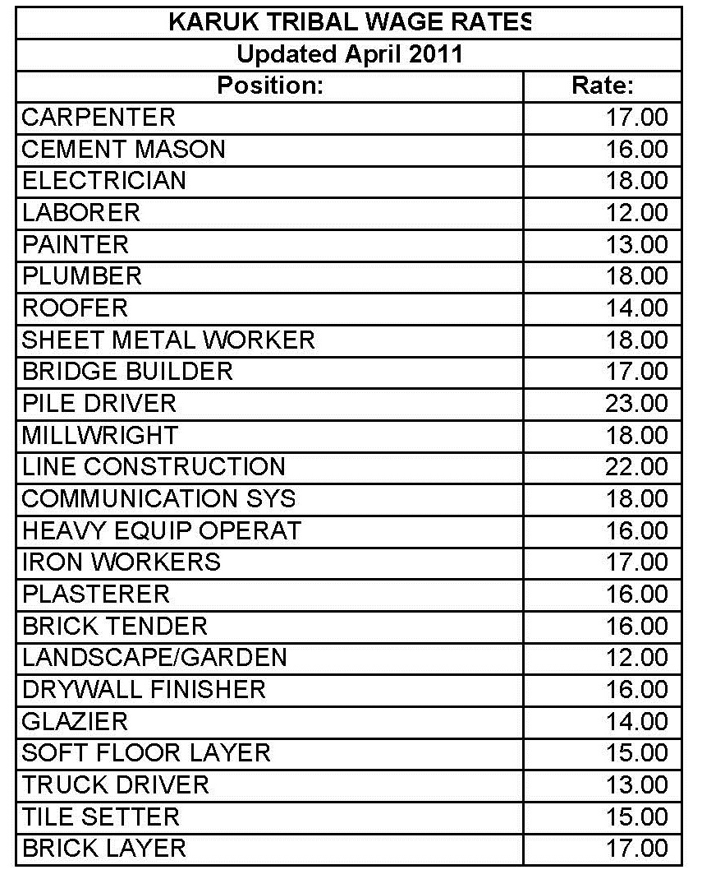

APPENDIX C
To Request for Lump Sum Fixed-Price Quotation

LUMP SUM FIXED PRICE QUOTATION

ITEM | PRICE
TRIBAL SALES TAX (6%) OF MATERIALS: | $
SUBTOTAL: | $
TERO FEE (2%) OF SUBTOTAL: | $
TOTAL QUOTATION AMOUNT: | $

APPENDIX D
To Request for Lump Sum Fixed-Price Quotation

TRIBAL EMPLOYMENT RIGHTS OFFICE
COMPLIANCE PLAN FOR BIDDERS

Bidder/Employer Name:

Mailing Address:

City, State and Zip Code:

Contact Person: Phone Number:

E-mail:

Base Bid  Without TERO: | $ | TERO Fee  2% of Base Bid: | $ | Total Bid  Base + TERO: | $

THIS IS AN AGREEMENT BETWEEN THE KARUK TRIBE’S TRIBAL EMPLOYMENT RIGHTS OFFICE (TERO) AND , HEREINAFTER KNOWN AS “EMPLOYER” CONDUCTING COMMERCE AND EMPLOYMENT ACTIVITY WITHIN THE ANCESTRAL TERRITORY OF THE KARUK TRIBE.

- Employer shall provide the completed compliance plan with the submission of bid.

- Upon notification of the award, Employer shall contact the TERO Office within ten (10) days prior to any work to be performed.

- Employer shall contact the TERO Office and Contract/Project Manager immediately, in writing, advising of any contract or sub-contractor changes to obtain approval prior to working on the job site.

- Employer understands and agrees to comply with the requirements and procedures in the selection of contractors, sub-contractors, employees and recruitment of viable Indian applicants in accordance with the Karuk Tribe’s Employment Rights Ordinance and the Karuk Tribe’s Workforce Protection Act (WPA).

By signing below the Employer certifies the position information is true and correct and there have been no omissions in the completion of the labor force projections. Falsification of the information provided will result in sanctions, penalties, fines and/or debarment with the Karuk Tribe.

Employer Signature Date

PRE-AWARD LABOR FORCE PROJECTION

Core Crew: Is defined as a member of a business, Contractor or Subcontractor’s crew who is a regular employee and is in a supervisory or other key position such that the employer would face a serious financial loss if that position were filled by a person who had not previously worked for that employer.
Laborer positions will be filled by the TERO office unless sufficient justification can be made that they are not replaceable for the work that is to be done.

List Core Crew (Full Name): Job Title/ Years w/Company/Justification:

List Native American Contractors/Sub-contractors to be hired for this Project:

Contractor/Sub-contractor
Contact Person, Phone # and E-mail: Work to be Performed:

List Non-Native Contractor/Sub-contractors to be hired for this Project:

Contractor/Sub-contractor
Contact Person, Phone # and E-mail: Work to be Performed:

Open Positions: Employer agrees to hire 100% of all its open positions/Sub-contractors for this project through the TERO Skills Bank. If Employer is unable to hire 100% then company representatives will need to meet with the TERO Director. Failure to comply with this hiring requirement will result in sanctions and/or penalties.

Job Title/Sub-contractor Needed: Skills Required:

Number of positions to be filled for this project:
For Internal Use Only:

Contract Number #: Project Manager:

TERO Office Approval: Date:

Comments:

